BS Education
2ND SEMESTER (Session 2023-27 on wards)

Course Code | Course Title | Category | CH
GEN-3201 | Expository Writing | GE | 3(3+0)
GEN-3202 | Application of Information and Communication  Technologies | GE | 3(2+1)
GEN-3203 | Introduction to Philosophy | GE | 2(2+0)
GEN-3204 | Civic and Community Engagement | GE | 2(2+0)
GEN-3205 | Introduction to Psychology | GE | 2(2+0)
EDU-3206 | Classroom Management | MC | 3(3+0)
EDU-3207 | Foundation of Education | MC | 3(3+0)
HQT-3208 | Holy Ouran with Translation. Tajveed & Tafseer | COM | S/U
 | Total Credit hours |  | 18
COURSE CONTENTS FOR SEMESTER-II

GEN-3201 Expository Writing Credit Hours: 3(3)
Course Objectives: The course is developed with the aim to enable the students to meet their real life communication needs by
● Helping them learn and understand basic concepts of communication process ● Practically implementing theoretical aspects in the real life situations Course Contents:
What is Communication?
▪ Process of communication, effective steps of communication, basic communication skills
Paragraph Writing;
▪ Practice in writing a good, unified and coherent paragraphs
▪ Paragraph writing leading towards the writing of five to seven paragraphs long essay
▪ Stages of writing (brain storming, researching, drafting and editing)
▪ Methods of writing (cause and effect, problem solutions, comparison and contrast)
Essay Writing;
▪ Basic structure of essay, topic sentence, supporting sentence, concluding sentence, thesis statement
▪ Unity and Coherence, Introduction and Conclusion
CV and Job Application;
▪ Preparing a Curriculum Vitae
▪ Writing a formal job application
Translation Skills;
▪ Urdu to English
(Practice at advanced level)

Study Skills;
▪ Skimming and scanning, intensive, extensive and speed reading
▪ Summary and precis writing
▪ Comprehension (at advanced level)
▪ (sQ3R and Sq4r methods) Academic Writing;
▪ Letter/ Memo writing, Minutes of Meeting, use of Dictionary, Library and Internet
Presentation Skills;
▪ Personality development (emphasis on content, style and pronunciation)
▪ Preparation stage, audience analysis, handling and asking questions, managing time, handling non-verbal means, feedback
Academic Writing;
▪ How to write a research proposal for research paper/term paper?
▪ How to write a research paper/ term paper?
▪ (Emphasis on style, content, language, form, clarity , consistency)
Report Writing;
▪ Technical Report writing
▪ Progress report writing
▪ Preparation and planning
E-mail writing;
▪ Creating e-mail account
▪ Writing and sending e-mails
Preparing for Interview and Research proposal/ research paper defense
Note: Documentaries to be shown for discussion and review Recommended Books: Communication Skills
a) Grammar
1. Practical English Grammar by A. J. Thomson and A. V. Martinet. Exercises 2. Third edition. Oxford University Press 1986. ISBN 0 19 431350 6.
- Writing
  - Writing. Intermediate by Marie-Christine Boutin, Suzanne Brinand and Francoise Grellet. Oxford Supplementary Skills. Fourth Impression 1993. ISBN 019 435405 7 Pages 45-53 (note taking).
  - Writing. Upper-Intermediate by Rob Nolasco. Oxford Supplementary Skills. Fourth Impression 1992. ISBN 0 19 435406 5 (particularly good for writing memos, introduction to presentations, descriptive and argumentative writing).
- Reading
- Reading. Advanced. Brian Tomlinson and Rod Ellis. Oxford Supplementary Skills.
Third Impression 1991. ISBN 0 19 453403 0.
- Reading and Study Skills by John Langan 3. Study Skills by Richard York.
d) Speaking
- Ellen, K. 2002. Maximize Your Presentation Skills: How to Speak, Look and Act on Your Way to the Top
- Hargie, O. (ed.) Hand book of Communications Skills
- Mandel, S. 2000. Effective Presentation Skills: A Practical Guide Better Speaking
- Mark, P. 1996. Presenting in English. Language Teaching Publications
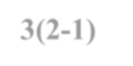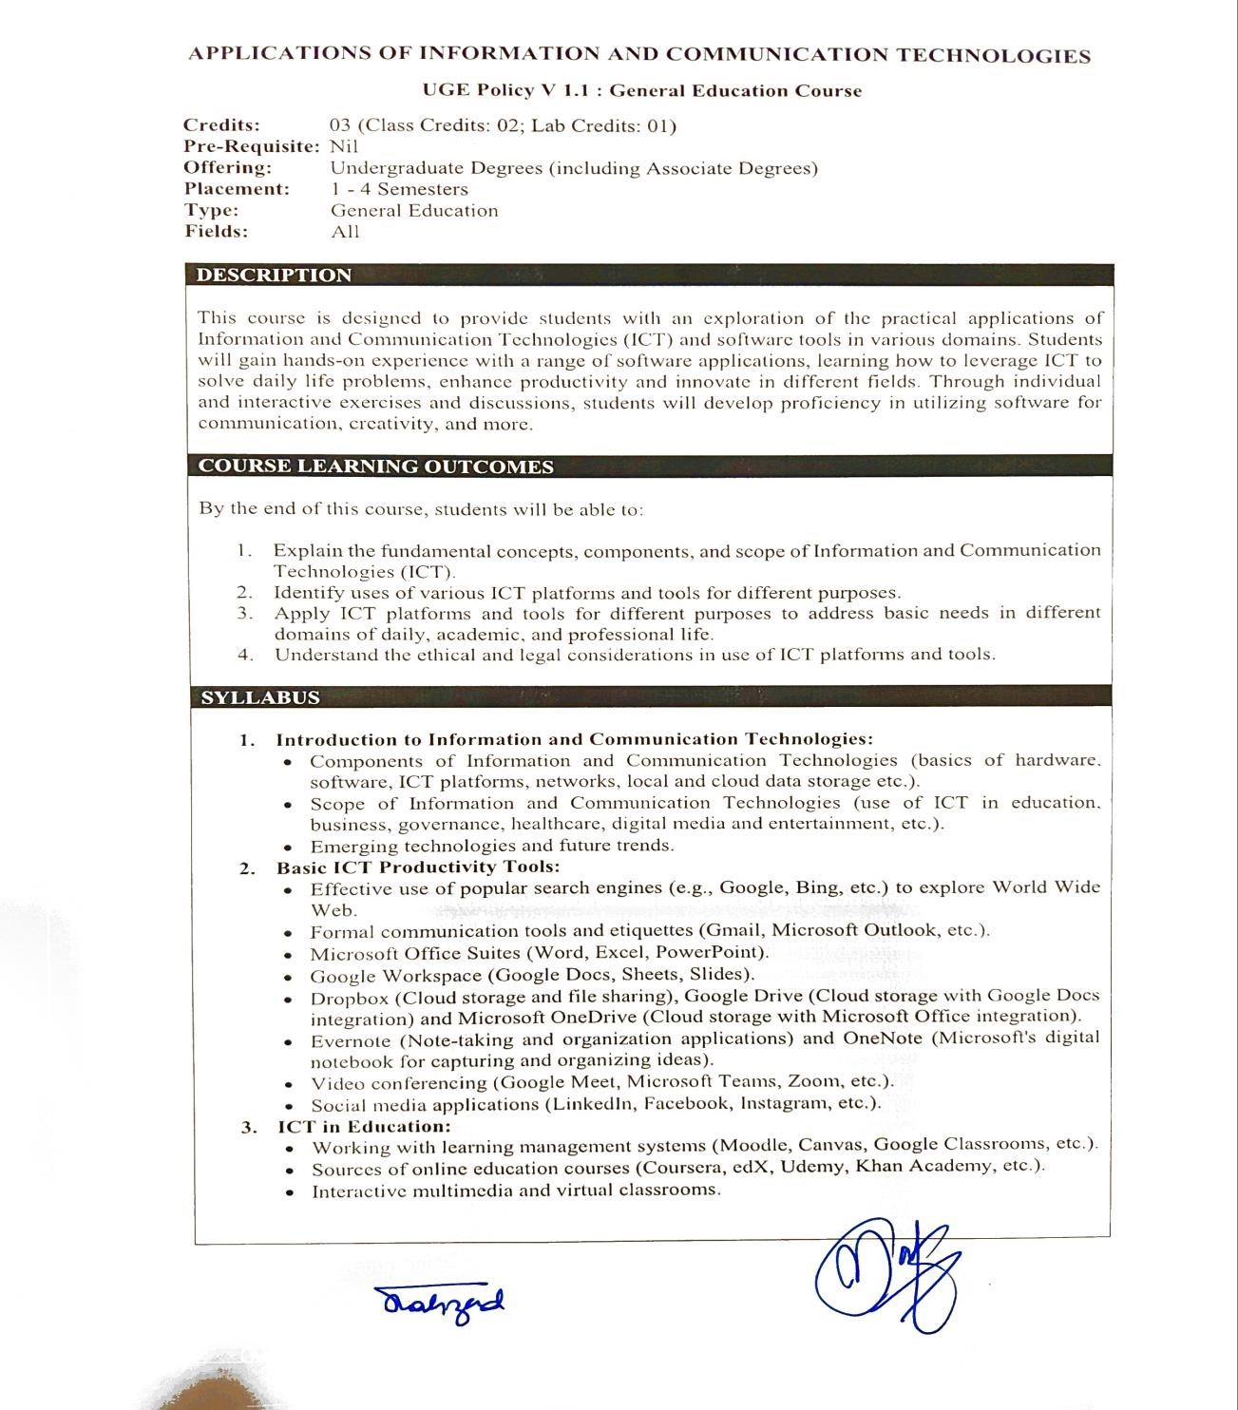

GEN
-
3202

Application of Information

and Communication Technologies
Credit Hours:
3(2
-
1)

Introduction to Philosophy Course Code:GEN-3203 Credit Hours: 2(2-0) Course Objectives: This course will help students to know how to discuss philosophical issues and how to use language for this purpose.

Course Contents:

Introduction to Philosophy
- Definition of Philosophy
- Etymology of Philosophy (c) Scope of Philosophy
(d) Nature of Philosophy.

Philosophical Questions
a. What Is Truth? b. What is Justice? c. What is Good? d. What is Beauty? e. What is Love? f. What Is the Meaning of Life? g. Is Knowledge Possible? h. What Does It Mean to Be Free? i. Are You Really You? j. How Does the Brain Produce the Mind? k. Does Happiness Define the Good? l. What Makes a Society Fair or Just?
TERMINAL COURSE

Branches of Philosophy:
(a) Metaphysics (b) Epistemology (c) Logic (d) Ethics (e) Political Philosophy (f) Aesthetics.

Historical Background of Philosophy:
(a) Ancient Greek Philosophy (b) Medieval Western and Muslim Philosophy (c) Modern Western Philosophy.

Philosophy and Social Sciences:
(a) Philosophy and Psychology (b) Philosophy and Sociology (c) Philosophy and Political Science (d) Philosophy and Literature

Recommended books
- Dr. Khalid Almas and KashifFaraz Ahmed ―Advanced Philosophy ―Advanced A P Publisher, Lahore.
- W. Russ Payne, ―An Introduction to Philosophy‖ Bellevue College, 2015.
- Edward Craig, ―Philosophy A Very Short Introduction‖ by Oxford University Press, Inc., New York 2002.
- Dallas M. Roark, Ph.D. ―Introduction to Philosophy―Emporia State University Copyright 1982 edition, 2016.
- Nigel Warburton ―Philosophy: The Basic‖ published byRoutledge, Fifth edition published 2013.
GEN
-
3204
Civics and Community Engagement

Course Code:

Credit Hours: 2
(2
-
0)

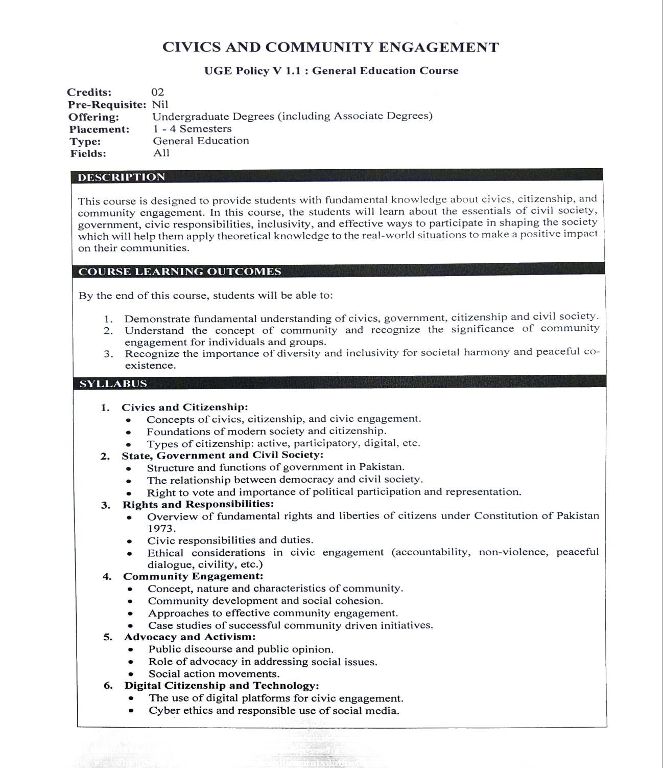

Course Code: GEN-3205
Course Title: Introduction to Psychology
Semester: 2nd
Credit Hrs.: 03

Learning Objectives:
Think of this course as a way to study an instruction manual for human thought and behavior. Although the manual is far from complete, it does contain some pretty interesting facts thus far. In exploring this manual, you will learn to learn the methods that psychologists use to approach questions about behavior, critical thinking skills necessary for approaching these questions, and how to apply what we already know about human behavior to everyday life. I want students to keep in mind that psychology is a science. Because it is a scientific enterprise, it is important that you become familiar with the empirical methods that scientists use to test their ideas. In addition, I want you to become more aware of some of the misconceptions about psychology. You will begin to learn how to dispel myths about human behavior by using critical thinking skills so that you may make more informed judgments about human behavior. In a nutshell, by learning about human behavior, you will learn how to remain open to new information, while using skepticism. There are a couple of additional outcomes that I expect you to achieve. These include the ability to:
⮚ Recognize and explain the scientific method and evaluate scientific information.
⮚ Discriminate between reliable and less reliable information in your decision-making In addition to these, there are also learning goals that you should achieve, which are specific to this course. They include the ability to:
⮚ Demonstrate how course concepts apply to daily living.
⮚ Understand that behavior, thoughts, and emotions are shaped by heredity, immediate environment, and culture.
⮚ Understand that people‘s experience of the world is subjective.
⮚ Recognize that psychological conclusions are based on the scientific method. It is also my hope that, as a result of having taken this class, you will be able to maintain an appreciation for psychological principles and their application to everyday life. Lastly, we will spend some time going over how people differ according to the culture that they live in.

Format
The format for this class will be a mixture of lecture, discussion, small group work, and other activities. Research shows us that people learn much better and retain the information that they learn much longer when they actively participate in the learning process, and I encourage you to do just that. Therefore, I encourage you to talk about what you are learning with others, write about it, relate it to past experiences, and apply it to your daily life.

Recommended Resources
⮚ Lilienfield, Lynn, Namy, & Woolf. (2009). Psychology: From Inquiry to
Understanding. Pearson: Boston, MA.
⮚ Passer, M.W & Smith, R.E. (2019). Psychology: the science of mind and behavior. 3rd Ed. McGraw-Hill, Sydney (Available online). Additional readings will be provided within course modules.

WEEKLY COURSE BREAKUP/ PLAN
Week No. | TOPICS TO BE TAUGHT | Assignments & Self Directed  Activities
WEEK 1 | TOPIC 1: What psychology is like? | Reading: Schools of thoughts  In psychology
 | Lecture 1: Definition and application of psychology
 | Lecture 2: Methods in psychology
 | Lecture 3: The work of psychologists, Branches of psychology
WEEK 2 | TOPIC 2: | Assignment # 1: Thinking Processes and concept formation
 | Lecture 1:
 | Lecture 2:
 | Lecture 3:
WEEK 3 | TOPIC 3: Sensory processes and perception
 | Lecture 1: Sense of vision, hearing,
 | Lecture 2: sense of smell, taste and touch
 | Lecture 3: from perception, depth perception, constancy,

 | movement perception, plasticity, individual differences
WEEK 4 | TOPIC 4: Attitudes
 | Lecture 1: Nature, Measurement and Theories of attitude
 | Lecture 2: Theories of attitude, factors in attitude change
 | Lecture 3: Attitudes and Behavior, Behavior and attitudes
WEEK 5 | TOPIC 5: Memory
 | Lecture 1 Definition, Types, Modals
 | Lecture 2: Memory disorders
 | Lecture 3: Forgetting
WEEK 6 | TOPIC 6: Motivation | Assignment # 2: Decision  Making and Problem Solving
 | Lecture 1: Motives, Theories of motivation
 | Lecture 2:, Biological and Social motivation
 | Lecture 3: Frustration and conflict of motives QUIZ 1
WEEK 7 | TOPIC 7: Emotion
 | Lecture 1: Expression and perception of emotions, physiology of emotions
 | Lecture 2: Theories of emotions
 | Lecture 3: Emotional Regulation
WEEK 8 | TOPIC 8: Revision
 | Lecture 1: Discussion
 | Lecture 2: Discussion
 | Lecture 3: MIDTERM EXAM
ABOVE MENTIONED TOPICS HAVE BEEN
COMPLETED BEFORE MIDTERM EXAM
WEEK 9 | TOPIC 9: Principles of Learning
 | Lecture 1: Classical Conditioning
 | Lecture 2: Operant Conditioning
 | Lecture 3: Cognitive learning

WEEK 10 | TOPIC 10: Personality
 | Lecture 1: Definition, Major approaches
 | Lecture 2: Measuring Personality
 | Lecture 3: Personality Disorders
WEEK 11 | Social Psychology
 | Lecture 1: Social Perceptions
 | Lecture 2: Social Influence
 | Lecture 3: Social Relationships
WEEK 12 | TOPIC 12:
 | Lecture 1:
 | Lecture 2:
 | Lecture 3:
WEEK 13 | Topic 13: Stress, Health & Coping
 | Lecture 1: Characteristics of stressful events, psychological physical reactions to stress,
 | Lecture 2:, Coping skills, Managing stress
 | Lecture 3: QUIZ 2
WEEK 14

 | Lecture 1:
 | Lecture 2:
 | Lecture 3:
WEEK 15 | Presentations
 | Presentation 1: Cognitive Development
 | Presentation 2: Social and Emotional Development
 | Presentation 3: Moral Development
WEEK 16 | Psychology of Technology  1. Introduction to the Psychology of Technology:  -Discuss the interdisciplinary nature of the field,

drawing on insights from psychology, humancomputer interaction, sociology, and other disciplines.
2.Digital Well-being and Mental Health:
Examine the psychological effects of technology use on mental health and well-being, including topics such as internet addiction, social media use, digital detoxes, and strategies for promoting healthy technology habits.
- Cyber psychology and Virtual Communities: Investigate the psychological dynamics of online communities, virtual worlds, and social networking platforms.
Discuss topics such as social identity, group dynamics, online relationships, and the formation of digital communities.
- Ethical and Social Implications of Technology: Explore ethical considerations and societal implications of technological advancements, including topics such as digital privacy, data security, online harassment, and the digital divide.
- Technology-Assisted Interventions and Therapy: Examine the role of technology in mental health assessment, treatment and support.
- Emerging Trends and Future Directions:
Discuss topics such as artificial intelligence, virtual reality, wearable devices, and their potential applications in psychology research and practice.

By incorporating the psychology of technology as a chapter in course, teacher can provide students with valuable insights into the complex interactions
between individuals, technology, and society in the digital age. This addition can enhance students understanding of contemporary issues and phenomena related to technology use and its impact on human behavior and well-being.

Classroom Management Course Code: EDU-3206

Credit Hours 3 COURSE DESCRIPTION:

One of the foremost reasons cited for teacher burnout is the challenge of classroom management. This comes as little surprise since classrooms are crowded, busy places in which students of diverse backgrounds and learning styles must be organized, directed and actively involved in learning. Many events need to occur simultaneously, the course of these events is often unpredictable and teachers must react often and immediately to evolving problems and needs. Teaching in such settings requires a highly developed ability to manage people, space, time and activity.

A program of study that aims to prepare prospective teachers must, therefore, equip them with knowledge and strategies for become effective managers of classrooms. In its narrowest sense, classroom management is defined in terms of ‗disciplining‘ and ‗controlling‘ students. This course, however, places the goal of ‗student learning‘ at the heart of classroom management. That is, it views the best-managed classrooms as ones where each learner is effectively engaged in constructing knowledge. To this end, teachers must manage teaching content, plan lessons, develop responsive instructional strategies, differentiate instruction, create predictable structures and routines and connect learning to the real world outside the classroom. It also views the best managed classrooms as learning communities with shared values of respect and caring.

In this course, prospective teachers will be encouraged to explore their own beliefs about teaching and learning to arrive at a philosophy of classroom management that places
‗learning‘ as an ultimate goal. Prospective teachers will be given the chance to explore curricular concerns of ‗what to teach‘ and ‗how to teach it‘ and view lesson planning as the consequence of these decisions. They will also study research and best practices on differentiation of instruction, classroom structures, routines, procedures and communitybuilding.

COURSE OBJECTIVES:

After completing this course, prospective teachers will be able to:
- Define classroom management as a means to maximizing student learning.
- Identify key features of a well-managed classroom.
- Plan lessons, activities and assignments to maximize student learning.
- Differentiate instruction according to student needs, interests and levels.
- design and practice predictable classroom routines and structures to minimize disruptions
- plan for a culture of caring and community in the classroom

SEMESTER OUTLINE

Unit 1—Learning Theories and Classroom Management (4 weeks/12 hours)

Week  1 | Why a course on Classroom Management? How does a teacher‘s personal philosophy about teaching and learning affect his or her beliefs about classroom management?  What happens in a well-managed classroom?
Week  2 | Classroom Observations and Data Collection (students spend 6 hours in a classroom including class and out-of-class hours)
Week  3 | What are the features of Classroom Management? (physical environment, social environment)  What challenges must teachers negotiate in the management of a classroom?  How do classroom discipline and management differ?  What kind of classroom environment do I want?
Week  4 | What do I need to think about in designing the effective classroom environment? o Identifying resources for learning  - Using displays and visuals for enhancing the learning environment in  the classroom  - Seating arrangements for different kinds of learning experiences Physical facilities to enhance the learning environment o Building the social environment

Unit 2-- Curriculum and Classroom Management (4 weeks/12 hours)

Week  s 5-8 | How can my curriculum support the classroom management?  In what ways can the teacher create a plan for teaching and learning that is consistent with her/his philosophy?  planning, motivation, teaching and assessing the curriculum differentiation of instruction mufti-grade classrooms overcrowded classrooms

TERMINAL COURSE
Unit 3—Routines, Schedules and Time Management in Diverse Classrooms (3 weeks/9 hours)

Week  s 9 | What are classroom ‗routines‘ and ‗structures‘ and how do they help in the management of classroom time?  How do you create structures and routines in a multi-grade context?  How can routines and structures help me deal with special needs and situations?
10 | How might routines and structures be used to teach specific subject content like Math, Science or Literacy?
11 | How might routines and structures be used to promote cooperation and collaborative learning?

Unit 4—Creating Shared Values and Community (2 weeks/ 6 hours)

Week  12 | What is community inside and outside the classroom and school? What is community participation and involvement?
 | What are typical practices of community participation?
Week  13 | How can I manage involvement of the community in my classroom?  What routines and structures need to be put in place?  In what ways might community involvement be different in multi-grade classroom?
Week  14 | How can I create an ―ethic of care‖ in my classroom? o diverse classrooms as caring, democratic communities o respectful relations between teacher and students, students and  students
Week  15 | How can a caring classroom help me build responsible actions and personal accountability?  What happens when behavior breaks down?  How do I deal with unexpected events?

Unit 5—Planning the Classroom Environment I Would Like

Week 16 | How can I use what I have learned to create the classroom I want?  opener critique and review of final projects summary and closure

LEARNING AND TEACHING APPROACHES:
This course assumes that prospective teachers will develop their own plans for classroom management as a result of all they learn in the sixteen weeks that follow.
This course relies on peer discussions, independent reflections and class lectures. It also assumes that student teachers will read all the recommended text and ask provocative questions of themselves and during class. Students are expected to listen with tolerance to new points of view and contribute their understanding and experiences during discussions.

SUGGESTED RESOURCES
.

- Classroom Management That Works: Research-Based Strategies for Every Teacher by Robert J. Marzano, Jana S. Marzano, Debra Pickering

- http://smkbp.com/attachments/Ebook%20%20Classroom%20Management%20That% 20Works.pdf

- Chapter 1—Introduction to Proactive Classroom Management
- http://ptgmedia.pearsoncmg.com/images/9780135010631/downloads/Henley_Ch1_Int roducti ontoProactiveClassroomManagement.pdf

- The Multi-grade Classroom: A Resource handbook for Small Rural Schools- Book 3: Classroom Management and Discipline by Susan Vincent, Northwest Regional Educational Laboratory, Portland, Oregon 97204.
- http://educationnorthwest.org/webfm_send/1152

- Canter, L. Assertive discipline: More than names on the board and marbles in a jar. [Retrieved on February, 28, 2011] from
- http://campus.dyc.edu/~drwaltz/FoundLearnTheory/FLT_readings/Canter.htm
- Evertson, C., Poole, I., & the IRIS Center (n.d.) Norms and Expectations. [Retrieved on January, 20, 2011] from
http://iris.peabody.vanderbilt.edu/instructors/guides/case_studies/ICS-003ICpdf

- Evertson, C. M., & Emmer, E. T. (2009). Classroom management for elementary teachers (8th Ed.). Upper Saddle River, NJ: Pearson.

- Marzano, R. J. (2003). Classroom management that works: Research-based strategies for every teacher. Alexandria, VA: Association for Supervision and Curriculum Development. Marzano, R. J., Marzano, J. S., & Pickering, D. (2003).
Classroom Management That Works: Research-Based Strategies for Every Teacher. ASCD.

- Jones, F. H., & Jones, V. S. (2016). Tools for Teaching: Discipline, Instruction, Motivation. Fredric H. Jones & Associates.

- Charles, C. M., & Senter, G. W. (2008). Building Classroom Discipline. Pearson.

- Wong, H. K., Wong, R. T., & Seroyer, C. T. (2018). The First Days of School: How to Be an Effective Teacher. Harry K. Wong Publications.

- Kagan, S., & Kagan, M. (2009). Kagan Cooperative Learning. Kagan Publishing.

- Curwin, R. L., Mendler, A. N., & Mendler, B. (2008). Discipline with Dignity: New Challenges, New Solutions. ASCD.

FOUNDATIONS OF EDUCATION (FOUNDATION)

Course Code-3207 Credit Hours 3

Course Description
This course will focus on the ideological, philosophical, psychological, socio-economic and historical foundations of education. The major focus will be on developing an understanding of the participants how different philosophical theories affect education. The course will also include historical development of education of the Pakistan. Emphasize will be given on analyzing various sociological, political, economic and ideological forces that influence the process of education in our culture context. This course will also be used to develop the ability in prospective teachers to interpret knowledge within its historical, philosophical, ideological, and social contexts, which will lead to produce critical perspectives on education both within, and outside of, schools.
Learning outcome
The students will be able to:
- Explain the important features of foundation of education
- Specify the role of educational thinkers in education
- Discuss the modes of education
- Evaluate the issues and problems of education.

Course Outline

Unit 1 Ideological Foundation of Education
- Islamic Foundations
- Islamic concept of Peace
- Other religions and Islam
- Ideology and teachers

Unit 2 Philosophical Foundations of Education
- Philosophy and Education
- Main Philosophical Thoughts
- Idealism
- Realism
- `Pragmatism
- Re-constructionism

Unit 3 Psychological Foundations of Education
- Learning and Maturation
- Individual Differences
- Self-concept
- Academic Aptitude
- Instructional Strategies and Psychology
TERMINAL COURSE

Unit 4 Socio-Economic Foundations of Education
- Concept of Society and Culture
- Social Conditions and Education
- Economic Conditions and Education
- Politics and Education

Unit 5 Historical Foundations of Education in Pakistan
- Pre-Pakistan Period (712 A.D. to onward)
- Period from1947-1958
- Period From1959-1971
- Period from1972-1979
- Period from 1980-1991
- Period from 1992 – to date

Unit 6 Aims of Education
- Aims, Goals and Objectives
- Taxonomies of Objectives
- Aims and Objectives of Education in Pakistan

Unit 7 Problems and Issues in Education in
- Pakistan Universalization of Primary Education
- Literacy
- Medium of Instruction
- Diversification of Education
- Environmental Education
- Gender and Education
- Islamiazation of Education
- Special Education
- Health Education / Drug Education
- HIV / Aids, STIs,Hepatitis

Recommended Book
Canestrari, A. (2009). Foundations of Education. New York: Sage Publications. Eugene, F.P. (2005). Critical issues in education:
Anthology of reading. New York: Sage Publications.
Goldblatt, P.F., & Smith, D. (2005). Cases for teacher development. New York: Sage
Publications.
Holt, L.C. (2005). Instructional patterns: Strategies for maximizing students learning. Murphy, D. (2005). Foundations/Introduction to Teaching. USA: Allyn & Bacon, Inc.New York: SagePublications.
Semel, S. F. (2010). Foundations of education: The essential texts. USA: Routledge

